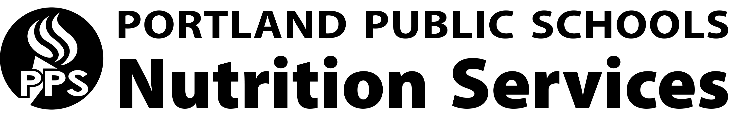
Clean Label Initiative
Our Mission:
To educate palates, inspire culinary curiosity and nourish the health of the community through school meals.

The Portland Public Schools Clean Label Initiative:
The Portland Public Schools Nutrition Service program is committed to serving delicious, nutrient-rich meals featuring whole foods. To accomplish this, we are implementing The Clean Label Initiative. We are working with farmers and vendors to reduce the following seven ingredients:

- High-Fructose Corn Syrup
- Artificial Colors
- Artificial Sweeteners
- Artificial Preservatives
- Trans Fats/Hydrogenated Oils
- Antibiotics in Chicken and Hormones and Antibiotics in beef and other animal products where possible.
- Bleached Flour

